

FPT University
Training Center Programming FPT - APTECH



SPUPORTIVE LEARNING

❖ SEM : IV
❖ CLASS : C0810G
❖ Group : Group 2
❖ TEACHER : Đỗ Quốc Bình
❖ Members :
- Dương Văn Định (Leader)
- Phan Văn Tuyền
- Trần Trung Hiếu
- Phạm Xuân Nam
- Vũ Đức Giang

- Problem Definition:
- Problem Abstraction: The thirst for learning, upgrading technical skills and applying the concepts in real life environment at a fast pace is what the industry demands from IT professionals today. However busy work schedules, far-flung locations, and unavailability of convenient time-slots pose as major barriers when it comes to applying the concepts into realism. And hence the need to look out for alternative means of implementation in the form of laddered approach.
- The Current System: The above truly pose as constraints especially for our students too! With their busy schedules, it is indeed difficult for our students to keep up with the genuine and constant need for integrated application which can be seen live especially so in the field of IT education where technology can change on the spur of a moment. Well, technology does come to our rescue at such times!!
- The Proposed System: Keeping the above in mind and in tune with our constant endeavour to use Technology in our training model, we at Aptech have thought of revolutionizing the way our students learn and implement the concepts using tools themselves by providing a live and synchronous eProject learning environment!
- Development Environment:
Hardware :
- Server:
- Pentium IV 3.06GHZ,RAM 1GB,HDD 160GB…
- Client:
- Pentium III 900GHZ,RAM 128MB,Sound & VGA Card…
Software :
- Server:
- OS Windows Server 2000 or Windows Server 2003.
- MS SQL Server 2005.
- Client:
- Window98 or higher operating system.

Developer Tools :
- Language Used : Java Web Application and JSF 2.0 PrimeFaces 2.2.1.
- Database : MS SQL Server 2005
- Design tool : Netbean 6.9.1

- Glassfish 3.0 or higher.

- Requirements and business Flow:
- Customer Requirement Specification:

  - System Requirement Specification :
- Student
- Staff
- Admin

  - Functionality for Student:

2.1. View Information:

Open website Student can view the brief description about Schools, about the assignments,and about the news.

2.2. Login:

Students must login for upload or download

2.3. Feedback:

Student can give feedbacks about the site or ask the queries if any.

2.4. Mark:

a. View details marks of assignments by roll number.

b. The students should be able to view the marks that are assigned for their assignments, through the link marks

2.5. FAQ’s:

Student can view the FAQ’s as created by the admin.

  - Functionality for Staff:

3.1. View Information:

Open website Staff can view the brief description about Schools, about the assignments,and about the news.

3.2. Login:

a. Staff must login to view, delete, upload assignments.

b. Staff can viewing uploaded files by student by roll number.

c. The staff will assign the marks after evaluating the assignment once they are downloaded. The marks assigned will then be uploaded on the site through the links “marks”, based on the roll number.

d. Staff to answer students' questions.

- Functionality for Admin:

4.1. Login:
a. The administrator will have the rights for creating, editing and deleting the usernames and passwords (username and passwords are to be created based on the batch, year, and semester. These are unique for the whole batch) .
b. The administrator will have the right to answer the query, view or edit or delete the FAQs.
- Activity Diagram

1. Login Activity Diagram:
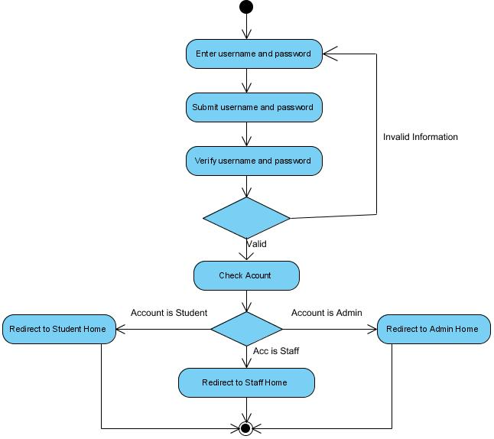

- Student Activity Diagram:

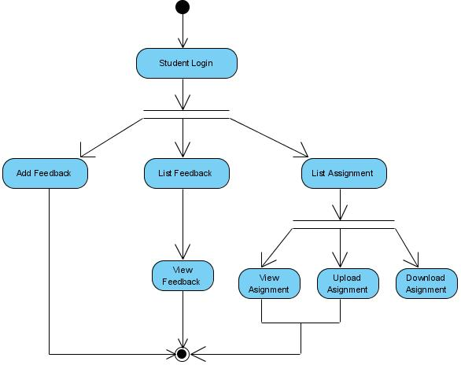

- Staff Activity Diagram:

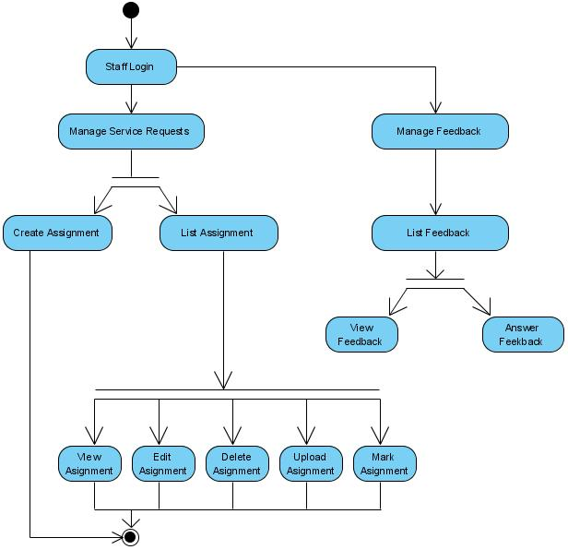

- Admin Activity Diagram:

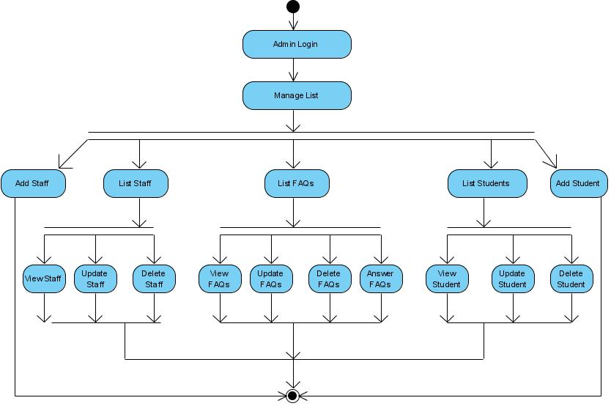

- Database Design

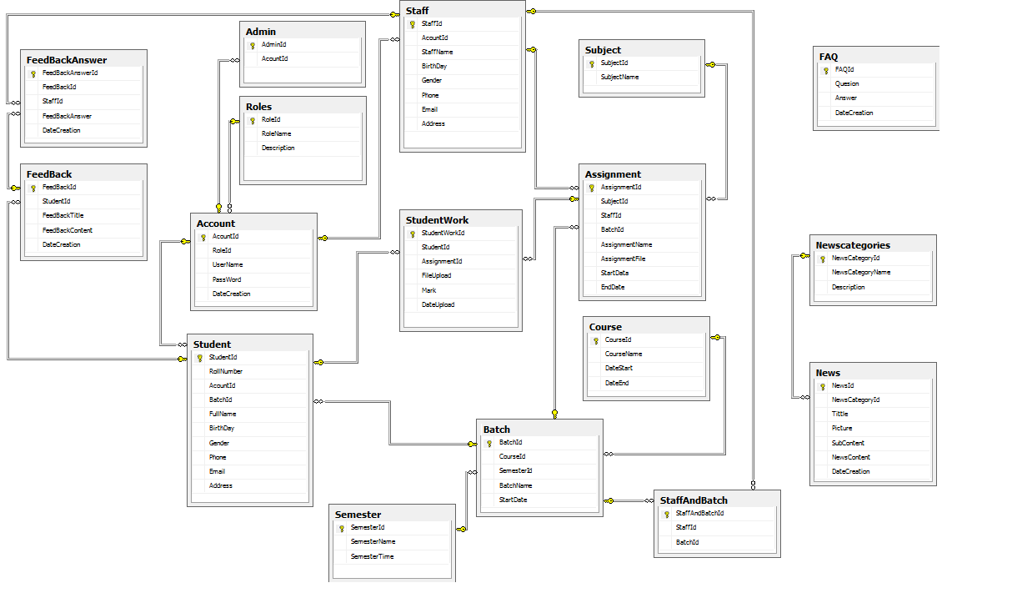

- User Case Diagram:

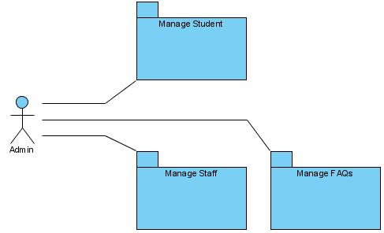

            - Admin Login User Case:

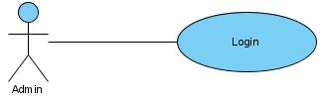

USE CASE # | UC01_01
USE CASE Name | Login
ACTOR | Admin
Purpose | Login to System Manager
Preconditions | Fill Username and Password
Postconditions in words | A new Batch login to System
Trigger | System Manage
Extended Use Cases
MAIN SUCCESSFUL SCENARIO | Actor Action | System Action
MAIN SUCCESSFUL SCENARIO | 1. Input Username and Password
MAIN SUCCESSFUL SCENARIO |  | 2. Check Username and Password (Validations)
MAIN SUCCESSFUL SCENARIO |  | 3. Login successfully
OTHER SUCCESSFUL SCENARIOS
UNSUCCESSFUL SCENARIOS | Conditions | Actions
UNSUCCESSFUL SCENARIOS | 2a. If data invalid | System will be appearing a dialog message “Username or Password invalid. Let try it”
Developer
Creation date and last modified date

            - Staff Login User Case:

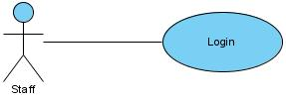

USE CASE # | UC02_01
USE CASE Name | Login
ACTOR | Staff
Purpose | - Login Staff to view, delete, upload assignments.  - Login Staff to viewing uploaded files by student by roll number.  - Login Staff to answer students' questions.  - The staff will assign the marks after evaluating the assignment once they are downloaded. The marks assigned will then be uploaded on the site through the links “marks”, based on the roll number.
Preconditions | Fill Username and Password
Postconditions in words | A new User login to System
Trigger | System Manage
Extended Use Cases
MAIN SUCCESSFUL SCENARIO | Actor Action | System Action
MAIN SUCCESSFUL SCENARIO | 1. Input Username and Password
MAIN SUCCESSFUL SCENARIO |  | 2. Check Username and Password (Validations)
MAIN SUCCESSFUL SCENARIO |  | 3. Login successfully
OTHER SUCCESSFUL SCENARIOS
UNSUCCESSFUL SCENARIOS | Conditions | Actions
UNSUCCESSFUL SCENARIOS | 2a. If data invalid | System will be appearing a dialog message “Username or Password invalid. Let try it”
Developer
Creation date and last modified date

            - Student Login User Case:

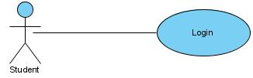

USE CASE # | UC03_03
USE CASE Name | Login
ACTOR | Student
Purpose | - Students must login for upload or download
Preconditions | Fill Username and Password
Postconditions in words | A new User login to System
Trigger | System Manage
Extended Use Cases
MAIN SUCCESSFUL SCENARIO | Actor Action | System Action
MAIN SUCCESSFUL SCENARIO | 1. Input Username and Password
MAIN SUCCESSFUL SCENARIO |  | 2. Check Username and Password (Validations)
MAIN SUCCESSFUL SCENARIO |  | 3. Login successfully
OTHER SUCCESSFUL SCENARIOS
UNSUCCESSFUL SCENARIOS | Conditions | Actions
UNSUCCESSFUL SCENARIOS | 2a. If data invalid | System will be appearing a dialog message “Username or Password invalid. Let try it”
Developer
Creation date and last modified date

            - Manage Batch User Case:

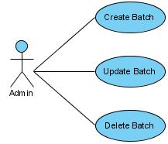

USE CASE # | UC04_01
USE CASE Name | Insert Batch
ACTOR | Admin
Purpose | Add a new Batch to System

Preconditions
Postconditions in words | A new Batch will be added to System
Trigger
Extended Use Cases
MAIN SUCCESSFUL SCENARIO | Actor Action | System Action
MAIN SUCCESSFUL SCENARIO | 1. Admin access to the system
MAIN SUCCESSFUL SCENARIO |  | 2. System display menu
MAIN SUCCESSFUL SCENARIO | 3. Admin select “Manager Batch”
MAIN SUCCESSFUL SCENARIO |  | 4. Form “Insert Batch” will be displayed
MAIN SUCCESSFUL SCENARIO | 5. Admin input information
MAIN SUCCESSFUL SCENARIO | 6. Click “Save” button
MAIN SUCCESSFUL SCENARIO |  | 7. System process information that admin entered then saved to the database
OTHER SUCCESSFUL SCENARIOS
UNSUCCESSFUL SCENARIOS | Conditions | Actions
UNSUCCESSFUL SCENARIOS | When admin click “Save” button to check the data was invalid | System will be appearing a dialog message “Information invalid. Let try it”
Developer
Creation date and last modified date

USE CASE # | UC04_02
USE CASE Name | Update Batch
ACTOR | Admin
Purpose | Edit Batch information

Preconditions
Postconditions in words | Edit Batch information that already in the system
Trigger
Extended Use Cases
MAIN SUCCESSFUL SCENARIO | Actor Action | System Action
MAIN SUCCESSFUL SCENARIO | 1. Admin access to the system
MAIN SUCCESSFUL SCENARIO |  | 2. System display menu
MAIN SUCCESSFUL SCENARIO | 3. Admin select “Manager Batch”
MAIN SUCCESSFUL SCENARIO |  | 4. All Information about Batch will be displayed
MAIN SUCCESSFUL SCENARIO | 5. Admin click “Edit” button
MAIN SUCCESSFUL SCENARIO | 6. Admin edit information
MAIN SUCCESSFUL SCENARIO | 7. Admin click “Update” button
MAIN SUCCESSFUL SCENARIO |  | 8. System process information that admin entered then saved to the database
OTHER SUCCESSFUL SCENARIOS
UNSUCCESSFUL SCENARIOS | Conditions | Actions
UNSUCCESSFUL SCENARIOS | When admin click “cancel” button | System will reset at previous information
Developer
Creation date and last modified date

USE CASE # | UC04_03
USE CASE Name | Delete Batch
ACTOR | Admin
Purpose | Delete Batch information

Preconditions
Postconditions in words | Delete Batch information that already in the system
Trigger
Extended Use Cases
MAIN SUCCESSFUL SCENARIO | Actor Action | System Action
MAIN SUCCESSFUL SCENARIO | 1. Admin access to the system
MAIN SUCCESSFUL SCENARIO |  | 2. System display menu
MAIN SUCCESSFUL SCENARIO | 3. Admin select “Manager Batch”
MAIN SUCCESSFUL SCENARIO |  | 4. All Information about Batch will be displayed
MAIN SUCCESSFUL SCENARIO | 5. Admin click “Delete” button
MAIN SUCCESSFUL SCENARIO | 6. Admin delete information
MAIN SUCCESSFUL SCENARIO | 7. Admin click “Delete” button
MAIN SUCCESSFUL SCENARIO |  | 8. System process :  - Delete information related to Batch.
OTHER SUCCESSFUL SCENARIOS
UNSUCCESSFUL SCENARIOS | Conditions | Actions
UNSUCCESSFUL SCENARIOS | When admin click “cancel” button | System will reset at previous information
Developer
Creation date and last modified date

            - Manage Student User Case:

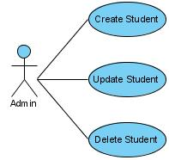

USE CASE # | UC05_01
USE CASE Name | Insert Student
ACTOR | Admin
Purpose | Add a new Student to System

Preconditions
Postconditions in words | A new Student will be added to System
Trigger
Extended Use Cases
MAIN SUCCESSFUL SCENARIO | Actor Action | System Action
MAIN SUCCESSFUL SCENARIO | 1. Admin access to the system
MAIN SUCCESSFUL SCENARIO |  | 2. System display menu
MAIN SUCCESSFUL SCENARIO | 3. Admin select “Manager Student”
MAIN SUCCESSFUL SCENARIO |  | 4. Form “Insert Student” will be displayed
MAIN SUCCESSFUL SCENARIO | 5. Admin input information
MAIN SUCCESSFUL SCENARIO | 6. Click “Save” button
MAIN SUCCESSFUL SCENARIO |  | 7. System process information that admin entered then saved to the database
OTHER SUCCESSFUL SCENARIOS
UNSUCCESSFUL SCENARIOS | Conditions | Actions
UNSUCCESSFUL SCENARIOS | When admin click “Save” button to check the data was invalid | System will be appearing a dialog message “Information invalid. Let try it”
Developer
Creation date and last modified date

USE CASE # | UC05_02
USE CASE Name | Update Student
ACTOR | Admin
Purpose | Edit Student information

Preconditions
Postconditions in words | Edit Student information that already in the system
Trigger
Extended Use Cases
MAIN SUCCESSFUL SCENARIO | Actor Action | System Action
MAIN SUCCESSFUL SCENARIO | 1. Admin access to the system
MAIN SUCCESSFUL SCENARIO |  | 2. System display menu
MAIN SUCCESSFUL SCENARIO | 3. Admin select “Manager Student”
MAIN SUCCESSFUL SCENARIO |  | 4. All Information about Student will be displayed
MAIN SUCCESSFUL SCENARIO | 5. Admin click “Edit” button
MAIN SUCCESSFUL SCENARIO | 6. Admin edit information
MAIN SUCCESSFUL SCENARIO | 7. Admin click “Update” button
MAIN SUCCESSFUL SCENARIO |  | 8. System process information that admin entered then saved to the database
OTHER SUCCESSFUL SCENARIOS
UNSUCCESSFUL SCENARIOS | Conditions | Actions
UNSUCCESSFUL SCENARIOS | When admin click “cancel” button | System will reset at previous information
Developer
Creation date and last modified date

USE CASE # | UC05_03
USE CASE Name | Delete Student
ACTOR | Admin
Purpose | Delete Student information

Preconditions
Postconditions in words | Delete Student information that already in the system
Trigger
Extended Use Cases
MAIN SUCCESSFUL SCENARIO | Actor Action | System Action
MAIN SUCCESSFUL SCENARIO | 1. Admin access to the system
MAIN SUCCESSFUL SCENARIO |  | 2. System display menu
MAIN SUCCESSFUL SCENARIO | 3. Admin select “Manager Student”
MAIN SUCCESSFUL SCENARIO |  | 4. All Information about Student will be displayed
MAIN SUCCESSFUL SCENARIO | 5. Admin click “Delete” button
MAIN SUCCESSFUL SCENARIO | 6. Admin delete information
MAIN SUCCESSFUL SCENARIO | 7. Admin click “Delete” button
MAIN SUCCESSFUL SCENARIO |  | 8. System process :  - Delete information related to Student.
OTHER SUCCESSFUL SCENARIOS
UNSUCCESSFUL SCENARIOS | Conditions | Actions
UNSUCCESSFUL SCENARIOS | When admin click “cancel” button | System will reset at previous information
Developer
Creation date and last modified date

            - Manage Course User Case:

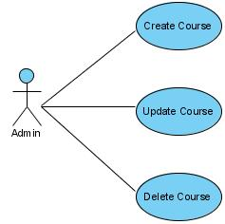

USE CASE # | UC06_01
USE CASE Name | Insert Course
ACTOR | Admin
Purpose | Add a new Course to System

Preconditions
Postconditions in words | A new Course will be added to System
Trigger
Extended Use Cases
MAIN SUCCESSFUL SCENARIO | Actor Action | System Action
MAIN SUCCESSFUL SCENARIO | 1. Admin access to the system
MAIN SUCCESSFUL SCENARIO |  | 2. System display menu
MAIN SUCCESSFUL SCENARIO | 3. Admin select “Manager ”
MAIN SUCCESSFUL SCENARIO |  | 4. Form “Insert Course” will be displayed
MAIN SUCCESSFUL SCENARIO | 5. Admin input information
MAIN SUCCESSFUL SCENARIO | 6. Click “Save” button
MAIN SUCCESSFUL SCENARIO |  | 7. System process information that admin entered then saved to the database
OTHER SUCCESSFUL SCENARIOS
UNSUCCESSFUL SCENARIOS | Conditions | Actions
UNSUCCESSFUL SCENARIOS | When admin click “Save” button to check the data was invalid | System will be appearing a dialog message “Information invalid. Let try it”
Developer
Creation date and last modified date

USE CASE # | UC06_02
USE CASE Name | Update Course
ACTOR | Admin
Purpose | Edit Course

Preconditions
Postconditions in words | Edit Course information that already in the system
Trigger
Extended Use Cases
MAIN SUCCESSFUL SCENARIO | Actor Action | System Action
MAIN SUCCESSFUL SCENARIO | 1. Admin access to the system
MAIN SUCCESSFUL SCENARIO |  | 2. System display menu
MAIN SUCCESSFUL SCENARIO | 3. Admin select “Manager Course”
MAIN SUCCESSFUL SCENARIO |  | 4. All Information about Course will be displayed
MAIN SUCCESSFUL SCENARIO | 5. Admin click “Edit” button
MAIN SUCCESSFUL SCENARIO | 6. Admin edit information
MAIN SUCCESSFUL SCENARIO | 7. Admin click “Update” button
MAIN SUCCESSFUL SCENARIO |  | 8. System process information that admin entered then saved to the database
OTHER SUCCESSFUL SCENARIOS
UNSUCCESSFUL SCENARIOS | Conditions | Actions
UNSUCCESSFUL SCENARIOS | When admin click “cancel” button | System will reset at previous information
Developer
Creation date and last modified date

USE CASE # | UC06_03
USE CASE Name | Delete Course
ACTOR | Admin
Purpose | Delete Course information

Preconditions
Postconditions in words | Delete Course information that already in the system
Trigger
Extended Use Cases
MAIN SUCCESSFUL SCENARIO | Actor Action | System Action
MAIN SUCCESSFUL SCENARIO | 1. Admin access to the system
MAIN SUCCESSFUL SCENARIO |  | 2. System display menu
MAIN SUCCESSFUL SCENARIO | 3. Admin select “Manager Course”
MAIN SUCCESSFUL SCENARIO |  | 4. All Information about Course will be displayed
MAIN SUCCESSFUL SCENARIO | 5. Admin click “Delete” button
MAIN SUCCESSFUL SCENARIO | 6. Admin delete information
MAIN SUCCESSFUL SCENARIO | 7. Admin click “Delete” button
MAIN SUCCESSFUL SCENARIO |  | 8. System process :  - Delete information related to Course.
OTHER SUCCESSFUL SCENARIOS
UNSUCCESSFUL SCENARIOS | Conditions | Actions
UNSUCCESSFUL SCENARIOS | When admin click “cancel” button | System will reset at previous information
Developer
Creation date and last modified date

            - Manage Staff User Case:

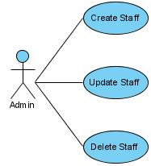

USE CASE # | UC07_01
USE CASE Name | Insert Staff
ACTOR | Admin
Purpose | Add a new Staff to System

Preconditions
Postconditions in words | A new Staff will be added to System
Trigger
Extended Use Cases
MAIN SUCCESSFUL SCENARIO | Actor Action | System Action
MAIN SUCCESSFUL SCENARIO | 1. Admin access to the system
MAIN SUCCESSFUL SCENARIO |  | 2. System display menu
MAIN SUCCESSFUL SCENARIO | 3. Admin select “Manager Staff ”
MAIN SUCCESSFUL SCENARIO |  | 4. Form “Insert Staff” will be displayed
MAIN SUCCESSFUL SCENARIO | 5. Admin input information
MAIN SUCCESSFUL SCENARIO | 6. Click “Save” button
MAIN SUCCESSFUL SCENARIO |  | 7. System process information that admin entered then saved to the database
OTHER SUCCESSFUL SCENARIOS
UNSUCCESSFUL SCENARIOS | Conditions | Actions
UNSUCCESSFUL SCENARIOS | When admin click “Save” button to check the data was invalid | System will be appearing a dialog message “Information invalid. Let try it”
Developer
Creation date and last modified date

USE CASE # | UC07_02
USE CASE Name | Update Staff
ACTOR | Admin
Purpose | Edit Course

Preconditions
Postconditions in words | Edit Staff information that already in the system
Trigger
Extended Use Cases
MAIN SUCCESSFUL SCENARIO | Actor Action | System Action
MAIN SUCCESSFUL SCENARIO | 1. Admin access to the system
MAIN SUCCESSFUL SCENARIO |  | 2. System display menu
MAIN SUCCESSFUL SCENARIO | 3. Admin select “Manager Staff”
MAIN SUCCESSFUL SCENARIO |  | 4. All Information about Staff will be displayed
MAIN SUCCESSFUL SCENARIO | 5. Admin click “Edit” button
MAIN SUCCESSFUL SCENARIO | 6. Admin edit information
MAIN SUCCESSFUL SCENARIO | 7. Admin click “Update” button
MAIN SUCCESSFUL SCENARIO |  | 8. System process information that admin entered then saved to the database
OTHER SUCCESSFUL SCENARIOS
UNSUCCESSFUL SCENARIOS | Conditions | Actions
UNSUCCESSFUL SCENARIOS | When admin click “cancel” button | System will reset at previous information
Developer
Creation date and last modified date

USE CASE # | UC07_03
USE CASE Name | Delete Staff
ACTOR | Admin
Purpose | Delete Staff information

Preconditions
Postconditions in words | Delete Staff information that already in the system
Trigger
Extended Use Cases
MAIN SUCCESSFUL SCENARIO | Actor Action | System Action
MAIN SUCCESSFUL SCENARIO | 1. Admin access to the system
MAIN SUCCESSFUL SCENARIO |  | 2. System display menu
MAIN SUCCESSFUL SCENARIO | 3. Admin select “Manager Staff”
MAIN SUCCESSFUL SCENARIO |  | 4. All Information about Staff will be displayed
MAIN SUCCESSFUL SCENARIO | 5. Admin click “Delete” button
MAIN SUCCESSFUL SCENARIO | 6. Admin delete information
MAIN SUCCESSFUL SCENARIO | 7. Admin click “Delete” button
MAIN SUCCESSFUL SCENARIO |  | 8. System process :  - Delete information related to Staff.
OTHER SUCCESSFUL SCENARIOS
UNSUCCESSFUL SCENARIOS | Conditions | Actions
UNSUCCESSFUL SCENARIOS | When admin click “cancel” button | System will reset at previous information
Developer
Creation date and last modified date

            - Manage Staff User Case:

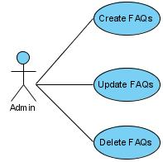

USE CASE # | UC08_01
USE CASE Name | Insert FAQs
ACTOR | Admin
Purpose | Add a new FAQs to System

Preconditions
Postconditions in words | A new FAQs will be added to System
Trigger
Extended Use Cases
MAIN SUCCESSFUL SCENARIO | Actor Action | System Action
MAIN SUCCESSFUL SCENARIO | 1. Admin access to the system
MAIN SUCCESSFUL SCENARIO |  | 2. System display menu
MAIN SUCCESSFUL SCENARIO | 3. Admin select “Manager FAQs ”
MAIN SUCCESSFUL SCENARIO |  | 4. Form “Insert FAQs” will be displayed
MAIN SUCCESSFUL SCENARIO | 5. Admin input information
MAIN SUCCESSFUL SCENARIO | 6. Click “Save” button
MAIN SUCCESSFUL SCENARIO |  | 7. System process information that admin entered then saved to the database
OTHER SUCCESSFUL SCENARIOS
UNSUCCESSFUL SCENARIOS | Conditions | Actions
UNSUCCESSFUL SCENARIOS | When admin click “Save” button to check the data was invalid | System will be appearing a dialog message “Information invalid. Let try it”
Developer
Creation date and last modified date

USE CASE # | UC08_02
USE CASE Name | Update FAQs
ACTOR | Admin
Purpose | Edit FAQs

Preconditions
Postconditions in words | Edit FAQs information that already in the system
Trigger
Extended Use Cases
MAIN SUCCESSFUL SCENARIO | Actor Action | System Action
MAIN SUCCESSFUL SCENARIO | 1. Admin access to the system
MAIN SUCCESSFUL SCENARIO |  | 2. System display menu
MAIN SUCCESSFUL SCENARIO | 3. Admin select “Manager FAQs”
MAIN SUCCESSFUL SCENARIO |  | 4. All Information about FAQs will be displayed
MAIN SUCCESSFUL SCENARIO | 5. Admin click “Edit” button
MAIN SUCCESSFUL SCENARIO | 6. Admin edit information
MAIN SUCCESSFUL SCENARIO | 7. Admin click “Update” button
MAIN SUCCESSFUL SCENARIO |  | 8. System process information that admin entered then saved to the database
OTHER SUCCESSFUL SCENARIOS
UNSUCCESSFUL SCENARIOS | Conditions | Actions
UNSUCCESSFUL SCENARIOS | When admin click “cancel” button | System will reset at previous information
Developer
Creation date and last modified date

USE CASE # | UC08_03
USE CASE Name | Delete FAQs
ACTOR | Admin
Purpose | Delete FAQs information

Preconditions
Postconditions in words | Delete FAQs information that already in the system
Trigger
Extended Use Cases
MAIN SUCCESSFUL SCENARIO | Actor Action | System Action
MAIN SUCCESSFUL SCENARIO | 1. Admin access to the system
MAIN SUCCESSFUL SCENARIO |  | 2. System display menu
MAIN SUCCESSFUL SCENARIO | 3. Admin select “Manager FAQs”
MAIN SUCCESSFUL SCENARIO |  | 4. All Information about FAQs will be displayed
MAIN SUCCESSFUL SCENARIO | 5. Admin click “Delete” button
MAIN SUCCESSFUL SCENARIO | 6. Admin delete information
MAIN SUCCESSFUL SCENARIO | 7. Admin click “Delete” button
MAIN SUCCESSFUL SCENARIO |  | 8. System process :  - Delete information related to FAQs.
OTHER SUCCESSFUL SCENARIOS
UNSUCCESSFUL SCENARIOS | Conditions | Actions
UNSUCCESSFUL SCENARIOS | When admin click “cancel” button | System will reset at previous information
Developer
Creation date and last modified date

            - Student Manage Use Case :

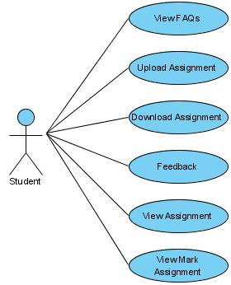

USE CASE # | UC09_01
USE CASE Name | View FAQs
ACTOR | STUDENT
Purpose | View FAQs

Preconditions
Postconditions in words | Student view FAQs
Trigger
Extended Use Cases
1. Student select
“FAQs” menu
 |  | 2. System display menu
 | 3. Student input information
 | 4. System display all FAQs
OTHER SUCCESSFUL SCENARIOS
UNSUCCESSFUL SCENARIOS | Conditions | Actions
Developer
Creation date and last modified date

USE CASE # | UC09_02
USE CASE Name | Upload Assignment
ACTOR | STUDENT
Purpose | Upload Assignment

Preconditions
Postconditions in words | Student Upload Assignment
Trigger
Extended Use Cases
1. Student select
“FileUpload” menu
 |  | 2. Student select file to upload
 | 3. Student click “Upload” button.
OTHER SUCCESSFUL SCENARIOS
UNSUCCESSFUL SCENARIOS | Conditions | Actions
Developer
Creation date and last modified date

USE CASE # | UC09_03
USE CASE Name | Download Assignment
ACTOR | STUDENT
Purpose | Download Assignment

Preconditions
Postconditions in words | Student download Assignment
Trigger
Extended Use Cases
1. Student select
“Link download” Assignment
 |  | 2. Student click to download
OTHER SUCCESSFUL SCENARIOS
UNSUCCESSFUL SCENARIOS | Conditions | Actions
Developer
Creation date and last modified date

USE CASE # | UC09_04
USE CASE Name | Send Feedback
ACTOR | STUDENT
Purpose | Send Feedback

Preconditions
Postconditions in words | Student send Feedback
Trigger
Extended Use Cases
 | 1. Student select “Feedback” menu
 |  | 2. Form “Feedback” will be displayed
 | 3. Student input information
 | 4. Student click “submit” button
 |  | 5. System process information that Student entered then saved to the database
OTHER SUCCESSFUL SCENARIOS
UNSUCCESSFUL SCENARIOS | Conditions | Actions
Developer
Creation date and last modified date

USE CASE # | UC09_05
USE CASE Name | View Assignment
ACTOR | STUDENT
Purpose | View Assignment

Preconditions

Postconditions in words
Trigger
Extended Use Cases
 | 1. Student select “List Assignment” menu
 |  | 2. Student select to view assignments
OTHER SUCCESSFUL SCENARIOS
UNSUCCESSFUL SCENARIOS | Conditions | Actions
Developer
Creation date and last modified date

USE CASE # | UC09_05
USE CASE Name | View Assignment
ACTOR | STUDENT
Purpose | View Assignment

Preconditions

Postconditions in words
Trigger
Extended Use Cases
 | 1. Student select “List Assignment” menu
 |  | 2. Student select to view assignments
OTHER SUCCESSFUL SCENARIOS
UNSUCCESSFUL SCENARIOS | Conditions | Actions
Developer
Creation date and last modified date

USE CASE # | UC09_06
USE CASE Name | View Mark
ACTOR | Student
Purpose | View Mark

Preconditions

Postconditions in words
Trigger
Extended Use Cases
 | 1. Student select form “MarkView”.
 |  | 2. Entered to Rollnumber click “Search” button.
 | 3. Student can view Mark
 |  | 5. System display “ Detail Mark”
OTHER SUCCESSFUL SCENARIOS
UNSUCCESSFUL SCENARIOS | Conditions | Actions
Developer
Creation date and last modified date

            - Staff Manage Use Case :

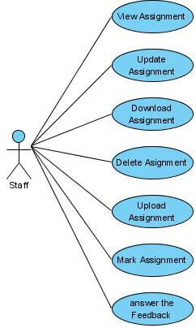

USE CASE # | UC10_01
USE CASE Name | View Asignment
ACTOR | Staf
Purpose | View Asignment

Preconditions

Postconditions in words
Trigger
Extended Use Cases
 | 1. Student select form “Asignment”.
 |  | 2. Upload Asignment.
 | 3. System display “Detail Assignment”
OTHER SUCCESSFUL SCENARIOS
UNSUCCESSFUL SCENARIOS | Conditions | Actions
Developer
Creation date and last modified date

USE CASE # | UC10_02
USE CASE Name | Mark Assignment
ACTOR | Staff
Purpose | Mark Assignment

Preconditions

Postconditions in words
Trigger
Extended Use Cases
 | 1. Staff select “List Assignment”.
 |  | 2. Download Assignment
 | 3. Evaluating the assignment once they are downloaded
 |  | 4. Upload Mark
OTHER SUCCESSFUL SCENARIOS
UNSUCCESSFUL SCENARIOS | Conditions | Actions
Developer
Creation date and last modified date

USE CASE # | UC10_03
USE CASE Name | Update Assignment
ACTOR | Staff
Purpose | Edit Assignment

Preconditions
Postconditions in words | Edit Assignment information that already in the system
Trigger
Extended Use Cases
MAIN SUCCESSFUL SCENARIO | Actor Action | System Action
MAIN SUCCESSFUL SCENARIO | 1. Staff access to the system
MAIN SUCCESSFUL SCENARIO |  | 2. System display menu
MAIN SUCCESSFUL SCENARIO | 3. Admin select “Manager Assignment”
MAIN SUCCESSFUL SCENARIO |  | 4. All Information about Assignment will be displayed
MAIN SUCCESSFUL SCENARIO | 5. Staff click “Edit” button
MAIN SUCCESSFUL SCENARIO | 6. Staff edit information
MAIN SUCCESSFUL SCENARIO | 7. Staff click “Update” button
MAIN SUCCESSFUL SCENARIO |  | 8. System process information that admin entered then saved to the database
OTHER SUCCESSFUL SCENARIOS
UNSUCCESSFUL SCENARIOS | Conditions | Actions
UNSUCCESSFUL SCENARIOS | When admin click “cancel” button | System will reset at previous information
Developer
Creation date and last modified date

USE CASE # | UC10_04
USE CASE Name | Download Assignment
ACTOR | Staff
Purpose | Download Assignment

Preconditions
Postconditions in words | Staff download Assignment
Trigger
Extended Use Cases
1. Staff select
“Link download” Assignment
 |  | 2. Staff click to download
OTHER SUCCESSFUL SCENARIOS
UNSUCCESSFUL SCENARIOS | Conditions | Actions
Developer
Creation date and last modified date

USE CASE # | UC10_05
USE CASE Name | Delete Assignment
ACTOR | Staff
Purpose | Delete Assignment information

Preconditions
Postconditions in words | Delete Assignment information that already in the system
Trigger
Extended Use Cases
MAIN SUCCESSFUL SCENARIO | Actor Action | System Action
MAIN SUCCESSFUL SCENARIO | 1. Staff access to the system
MAIN SUCCESSFUL SCENARIO |  | 2. System display menu
MAIN SUCCESSFUL SCENARIO | 3. Staff select “Manager Assignment”
MAIN SUCCESSFUL SCENARIO |  | 4. All Information about Assignment will be displayed
MAIN SUCCESSFUL SCENARIO | 5. Staff click “Delete” button
MAIN SUCCESSFUL SCENARIO |  | 6. System process :  - Delete information related to Assignment.
OTHER SUCCESSFUL SCENARIOS
UNSUCCESSFUL SCENARIOS | Conditions | Actions
UNSUCCESSFUL SCENARIOS | When admin click “cancel” button | System will reset at previous information
Developer
Creation date and last modified date

USE CASE # | UC10_06
USE CASE Name | Upload Assignment
ACTOR | Staff
Purpose | Upload Assignment

Preconditions
Postconditions in words | Staff Upload Assignment
Trigger
Extended Use Cases
1. Staff select
“FileUpload” menu
 |  | 2. Staff select file to upload
 | 3. Staff click “Upload” button.
OTHER SUCCESSFUL SCENARIOS
UNSUCCESSFUL SCENARIOS | Conditions | Actions
Developer
Creation date and last modified date

USE CASE # | UC10_07
USE CASE Name | Answer the Feedback
ACTOR | Staff
Purpose | Answer Feedback

Preconditions
Postconditions in words | Staff answer the Feedback
Trigger
Extended Use Cases
 | 1. Staff select “Feedback” menu
 |  | 2. Staff select question feedback click "Answer"
OTHER SUCCESSFUL SCENARIOS
UNSUCCESSFUL SCENARIOS | Conditions | Actions
Developer
Creation date and last modified date

